Name: Muhammad Tahir
CMS ID: 023-24-0196
Course: ADBMS Lab
ADBMS Lab 4
2026

exercise 1: window aggregates
select employee_id, salary,
avg(salary) over (partition by department_id) as dept_avg,
salary - avg(salary) over (partition by department_id) as diff
from employees;
solution:
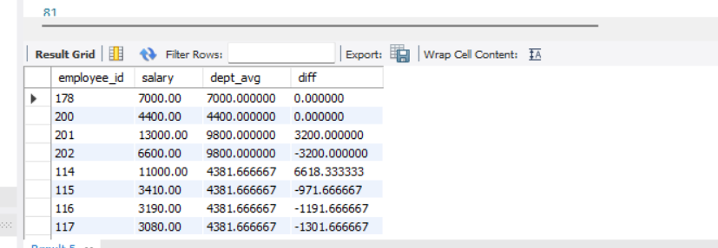

exercise 2: ranking functions
select employee_id, department_id, salary,
dense_rank() over (partition by department_id order by salary desc) as dept_rank
from employees;
solution:
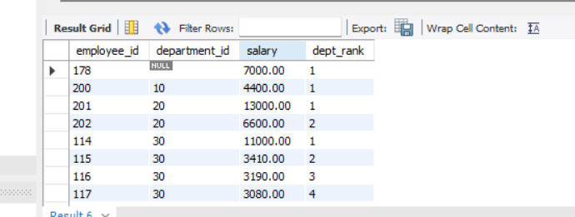

exercise 3: top-n per department
select *
from (
select employee_id, department_id, salary,
dense_rank() over (partition by department_id order by salary desc) as rnk
from employees
) t
where rnk <= 3;
solution:
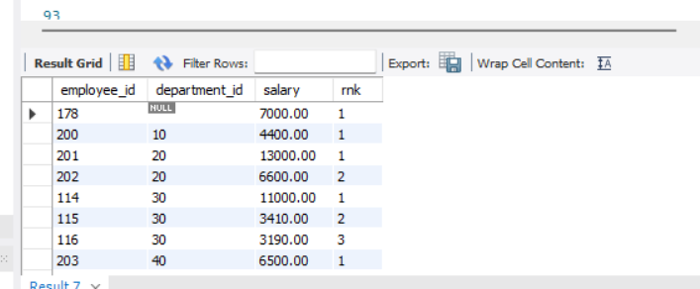

exercise 4: analytical functions (lag)
select employee_id, hire_date, salary,
salary - lag(salary) over (order by hire_date) as salary_diff
from employees;
solution:
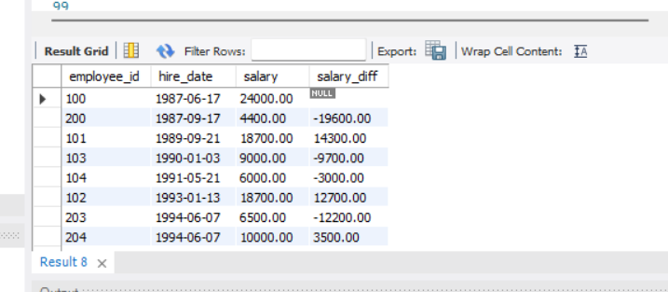

exercise 5: running totals

select employee_id, department_id, hire_date, salary,
sum(salary) over (
partition by department_id
order by hire_date
rows between unbounded preceding and current row
) as running_total
from employees;
solution:
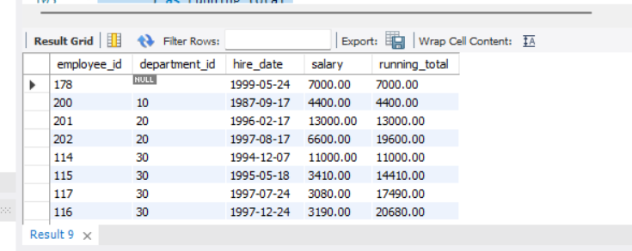

exercise 6: query optimization
-- non optimized
select * from employees where year(hire_date) = 2020;
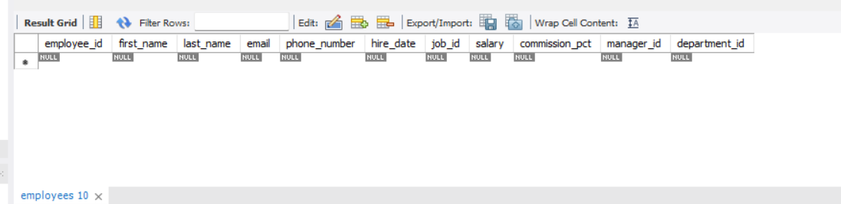
-- optimized
select * from employees
where hire_date between '2020-01-01' and '2020-12-31';
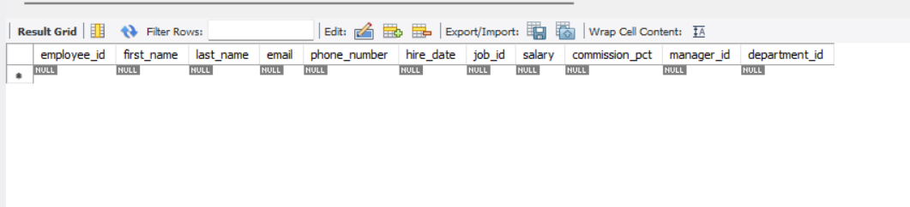
-- index creation
create index idx_hire_date on employees(hire_date);

exercise 7: explain analysis
explain
select e.employee_id, d.department_name
from employees e
join departments d on e.department_id = d.department_id;
solution:
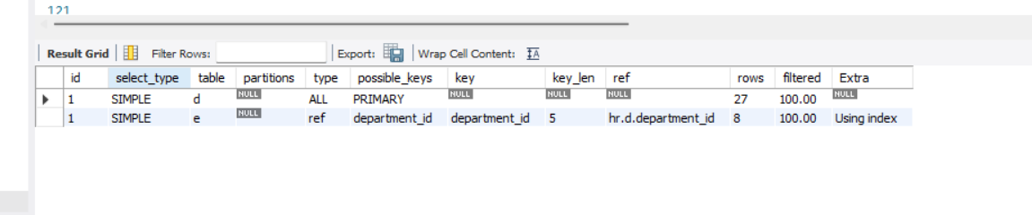

exercise 8: explain analyze
explain analyze
select * from employees where department_id = 10;
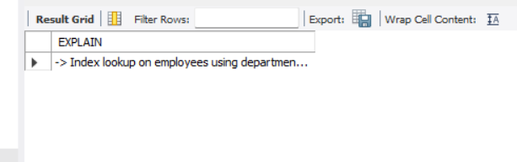

exercise 9: concurrency – lost update
set transaction isolation level serializable;
start transaction;
update accounts set balance = balance - 100 where id = 1;
commit;

exercise 10: isolation levels
set transaction isolation level read committed;
start transaction;
select * from employees where department_id = 5;
solution:
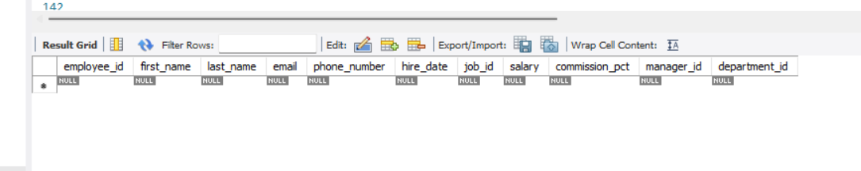

exercise 11: row level locking
start transaction;
select * from employees where employee_id = 101 for update;
solution:
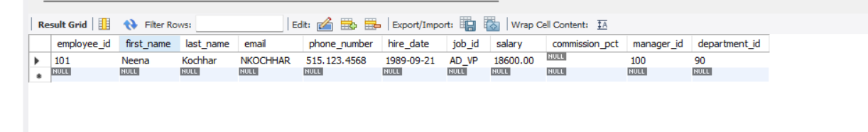

exercise 12: integrated case study
-- payroll report using window function
select employee_id, department_id, salary,
avg(salary) over (partition by department_id) as dept_avg
from employees;
Solution:
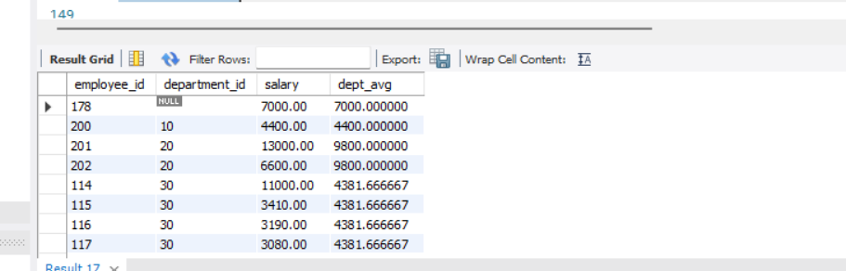
-- safe payroll update

